Conditional Knockout Mouse: https://getargeting-2026.vercel.app/conditional-knockout-mouse-models

- I love the idea of an image on these pages, but I don’t like the way AI is generating it (or how are you getting these)? We need to discuss a way to design a simple image that is consistent across model types, but not this:
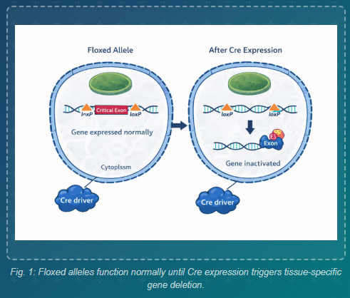

- Can you put in an “a” before Conditional Knockout:
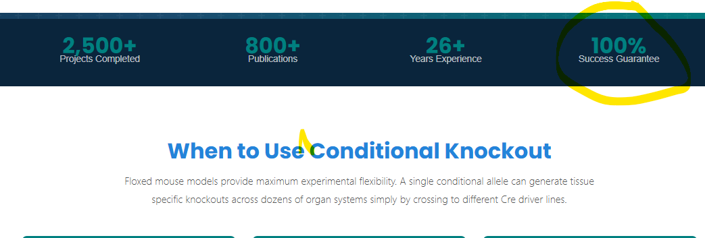

- This image isn’t correct as it is. We cannot use it this way:
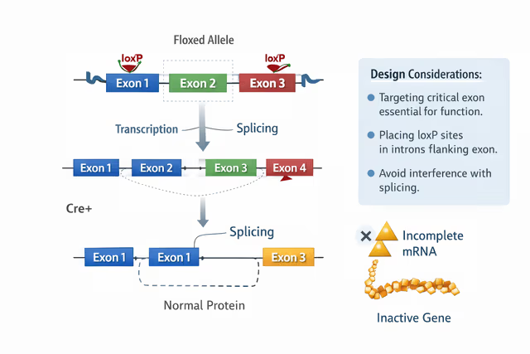

- These images created by AI are not accurate. For a company that specializes in this, we cannot use these images:


- Can you remove the word I crossed out in red and also, can you remove the link below, to the derivative system and delete that pages completely? I think this was one of the pages we said we weren’t going to use. This is a technology from another company. Also, I looked back to the final google doc version of this page and text is missing from the doc versus in this image. How do we fix that?
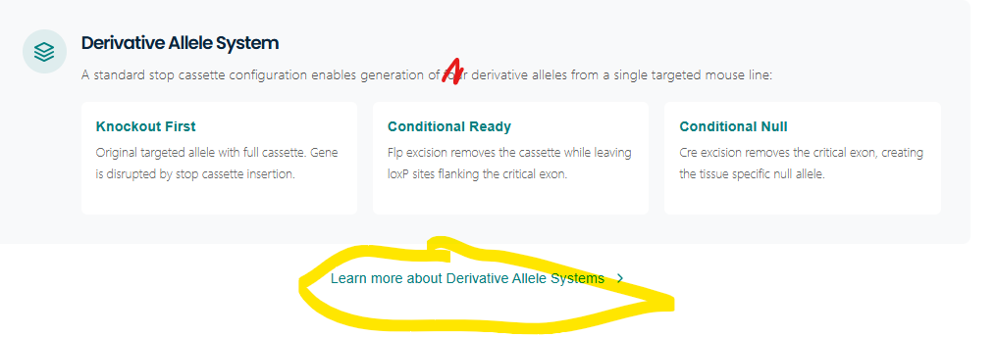
- This isn’t how Truview works. We need to remove the image. Also, do we have a Truview dedicated page? If so, we should link the text in this section to that page.
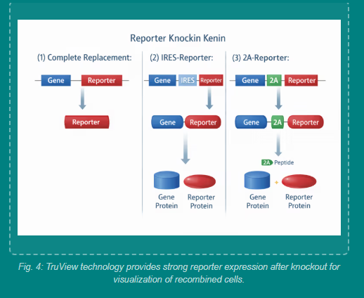

- These aren’t the publications from the final page version. Are you sure you’re using the final versions for the website? Please double check and update: 

- Let’s remove this timeline in the FAQ’s section:
